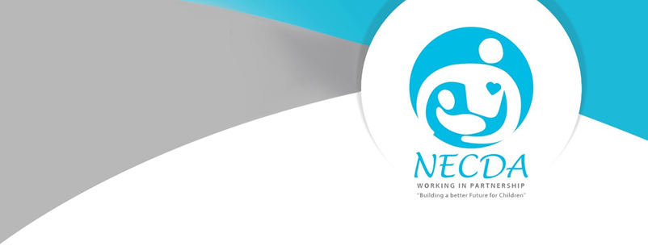

NATIONAL EARLY CHILDHOOD DEVELOPMENT ALLIANCE

NETWORK MEMBERSHIP APPLICATION FORM

1. ORGANISATION DETAILS/ INDIVIDUAL CONSULTANT

1.1 Contact details

Name of organisation:
Acronym: |  | Date founded:
Postal address:
City: |  | Postal code:
Street address:
Telephone: |  | Fax:
NPO number: |  | PBO number:
Website address: |  | Cellphone for SMS/ WhatsApp notifications:
Contact person
Name: |  | Designation:
Cellphone: |  | Email:

1.2 Which province is your main South African/head office based (please choose only one)?

Eastern Cape |  | KwaZulu-Natal |  | Northern Cape
Free State |  | Mpumalanga |  | Limpopo
Gauteng |  | North-West |  | Western Cape

1.4 Which province does your organisation operate within?
Eastern Cape |  | KwaZulu-Natal |  | Northern Cape
Free State |  | Mpumalanga |  | Limpopo
Gauteng |  | North-West |  | Western Cape
South Africa |  | Southern Africa |  | Africa

- ORGANISATION TYPE

How you are legally registered?
Academic Institution |  | Foundation/Trust
Company (for Profit) |  | NPO
Company (Section 21) |  | CBO
Technical Vocational Educational and Training (TVET) |  | Resource and Training Organisation (RTO)

- RTO INFORMATION
Please Specify :
- No. of Facilitators
- No. of Assessors
- No. of Moderators
- Are your Facilitators registered with the ETDP SETA((if not please indicate why) | YES / NO
- Indicate the number of Direct Beneficiaries ( i.e. practitioners reached annually )
- Indicate the number of indirect Beneficiaries (i.e.children) your programmes and services reach/ impact

3. WHAT SERVICES DO YOU PROVIDE or ISSUES DO YOU ADDRESS?

Adult Basic Education |  | Good Governance |  | Organisation Development
Advocacy |  | Health |  | Policy Development
Bursaries |  | HIV/Aids |  | Poverty Relief
Capacity Building |  | Human Resource Development |  | Publications
Children |  | Human Rights |  | Research
Civil Society Strengthening |  | Income Creation |  | Rural Development
Community Development |  | Information Technology for Communication |  | Sustainable Development
Counselling |  | Infrastructure |  | Training
Career Guidance |  | Job Creation |  | Urban Development
Disabled |  | Leadership Development |  | Welfare
Early Childhood Development |  | Literacy |  | Women
Family |  | Media |  | Youth
Food and Nutrition |  | Networking

4. Supporting Documents

4.1. Attach NPO certificate and profile if you are on applying as an organisation
4.2 . Attach CV and Profile if you are applying as an Individual

5. Terms and Conditions

5.1. Membership Compliance

5.1.1 In the event that your membership application is approved:
- Submit Audited Financial Statements (AFS) annually.
- Pay annual membership fees by the 31st May according to the
- membership tier you have selected failure to make payment will result in automatic cancellation and or lapse of membership.(however, if fees are received within one month after the stipulated date, the office of the Secretariat will reinstate your membership. Please contact the office in this regard).
- You are required to familiarise yourself with the NECDA’s Constitution and all related policies including the network structure.
- Register on the NECDA Membership Management System(MMS)
- Attend the Annual General Meeting in person, virtually and /or appoint a proxy to attend on your behalf.
- Ensure active participation in NECDA’s programmes, events and /or subcommittees.

    - If any changes occur within your organisation, it is it your responsibility to inform the Secretariat in writing and amend the contact information on the MMS.

6. REFERRALS

  - What other organisations are you a member of (please give full names and acronyms)?

Name of organisation and acronym | Contact details (telephone, website)

- Kindly provide a brief motivation for interest in joining NECDA.

8. POPPIA DISCLAIMER

7.1. I _______________________ the undersigned hereby consent to the following :

    - My organisations information may be collected, processed and recorded for the use of marketing and
statistical purposes, used on/in various platforms; be it in print, digital ,social media, strictly for the advancement of NECDA’s work.

7.1.2 Used by NECDA for the duration of my membership.

I therefore grant NECDA permission in accordance with the POPPI Act

Signed at __________________ on _________ of ____________ 2024 day

Applicant Signature : _____________________

Disclosure
*The National ECD Alliance reserves the right to approve/ not approve applications received in the event it does not meet the criteria.

* NECDA is a constituted membership based network made up of member organisations which derives its
mandate/ objectives from the membership.
For Office Use Only:

Approved by : ___________________________ Date : ________________________

Signature : _____________________________ Membership Number: _____________

Annual Membership Fees Structure / Tier

Annual Membership | Individual Member | Friend of NECDA | Professional Membership
Budget Under R1M (as on Annual Financial Statement) | R500 | R1 000 | 2500+
Budget Over R1M (as on Annual Financial Statement) | R500 | R2 000 | 2500+

Tier 1 : Individual Membership. Annual Cost: R500 per person
Member Benefits
- Receive NECDA communications, including newsletters, policy updates,
- Access to provincial structures and the NECDA member management system.
- Opportunities to attend the Annual General Meeting (AGM) learn and network with peers.
- Access to a basic digital resource library offering foundational resources on early childhood development (ECD).
- Opportunity to contribute to NECDA policy recommendations and advocacy efforts, amplifying members' voices in shaping the ECD landscape.
- Provide support to connect partners with funding opportunities
- Access to NECDA’s Recognition of Prior Learning (RPL) Subcom Skills Community, facilitating the validation and accreditation of informal and non-formal learning experiences.
- Skills building opportunities

Tier 2 : Friend of NECDA
Annual Cost per Organisation
- Annual Budget of <R1M: Annual Cost: R1000
- Annual Budget of <R1M: Annual Cost: R2000
Member Benefits
- NECDA communications, including newsletters, policy updates,
- provincial structures and the NECDA member management system.
- Opportunity to attend the Annual General Meeting (AGM) to learn and network with peers. This is limited to one person per organisation.
- Access to a basic digital resource library offering foundational resources on early childhood development (ECD).
- Opportunity to contribute to NECDA policy recommendations and advocacy efforts, amplifying members' voices in shaping the ECD landscape.
- Helping to connect partners with funding opportunities (e.g. learnerships
- Membership in the NECDA Recognition of Prior Learning (RPL) Skills Community, facilitating the validation and accreditation of informal and non-formal learning experiences.
- Skills building opportunities
- Membership is institutional and applies to all employees of a member organization

Tier 3: Professional Membership Annual Cost: R2,500 with the additional the costs indicated below
 | Description | Fees 2024
1 | CIPPT Membership Fees  Per person | R218
2 | RPL  Per person, per designation | R4,000
3 | CPD  Per person, per designation | From R100
Benefits:
- All the benefits of Tiers One and Two.
- Access to Chartered Institute of Professional Practitioners (CIPPT) membership for trainers within NECDA organizations. This includes advanced professional development opportunities, certification programs, and networking with a broader community of ECD professionals and RPL opportunities
- Support accessing SACE registration for ECD practitioners.

